

Dr. Jeffrey, Carter inc.
2015-09-15
Dr. Carter
USNS Saunders, FPO AP 50601
Phone: 7700873475
Fax: 8576503852

Re: Danielle, Holmes
PHN: 5310292789
Birthdate: 23-Apr-1942
Address: 43771 Elizabeth Circle Suite 934, Allenburgh, TX 53099
Patient number: 4138493282

To Whom It May Concern:

This is a medical letter to state the above patient is pregnant with expected delivery date of 24-May-2025. Hoping this information is satisfactory for your requirements.

Thank you.

Sincerely,
Dr. Jeffrey, Carter
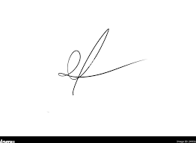
FRCS© NCMP
Clinical Assistant Professor, UBC
Department of Obstetrics and Gynecology SMH

